Eda (E xploratory
Data Analysis)

Week - 10

Report

Submitted by :

- Sahanaa sree
E25da045

Week - 10

Problem Statement:
The objective of this project is to analyze the House Sales dataset using Microsoft Power BI and create interactive dashboards to understand property sales, pricing trends, property characteristics, and overall housing market performance. The project focuses on transforming raw housing data into meaningful visual insights using data modeling, DAX measures, and different Power BI visualizations.

Objective :
. To analyze house sales data and identify important trends and patterns.
. To calculate key statistics such as average sales, maximum sales, minimum sales, and total sales.
. To evaluate property characteristics such as bedrooms, bathrooms, grade, condition, and living area.
. To compare renovated and non-renovated houses.
. To analyze waterfront and non-waterfront properties.
. To create interactive dashboards using Power BI.
. To improve decision-making through data visualization and analytical insights.

Tasks and Deliverables :

Data Import and Preparation :
Import the House Sales dataset into Power BI.
Examine the dataset and identify relevant columns.
Clean and organize the data for analysis.
Prepare the data for visualization and calculations

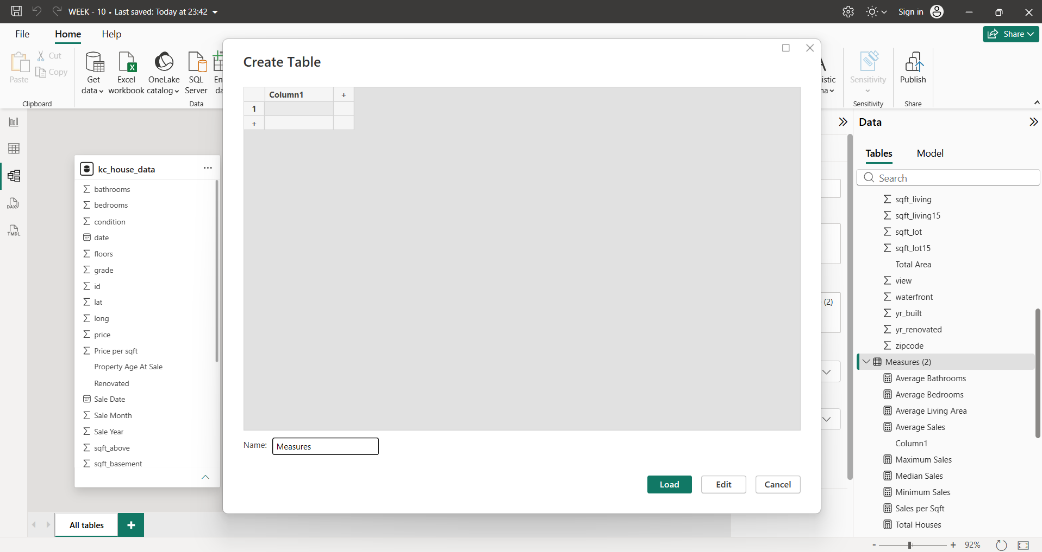

2. Data Modeling and DAX Measures :

. Create a separate Measures table.
. Establish the required data model.
. Create DAX measures to calculate:
. Average Sales
. Maximum Sales
. Minimum Sales
. Median Sales
. Total Sales
. Total Houses
. Average Bedrooms
. Average Bathrooms
. Average Living Area
. Average Lot Area
. Average Grade
. Average Property Age
. Average Price per Bedroom
. Average Price per Bathroom
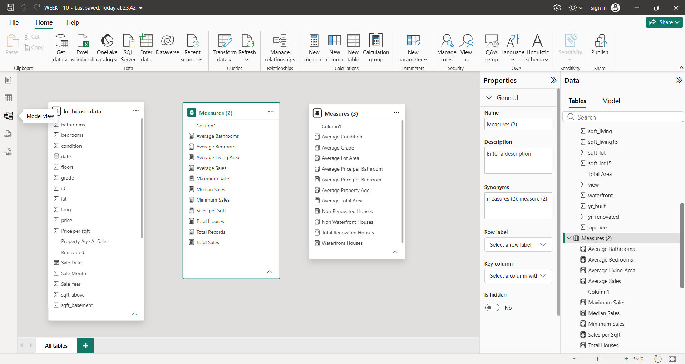

3. Dashboard Development:
page 1 – Property Characteristics Analysis
. Analyze average bedrooms and bathrooms.
. Visualize property condition and grade.
. Compare different property features.
. Display total property prices and other key metric

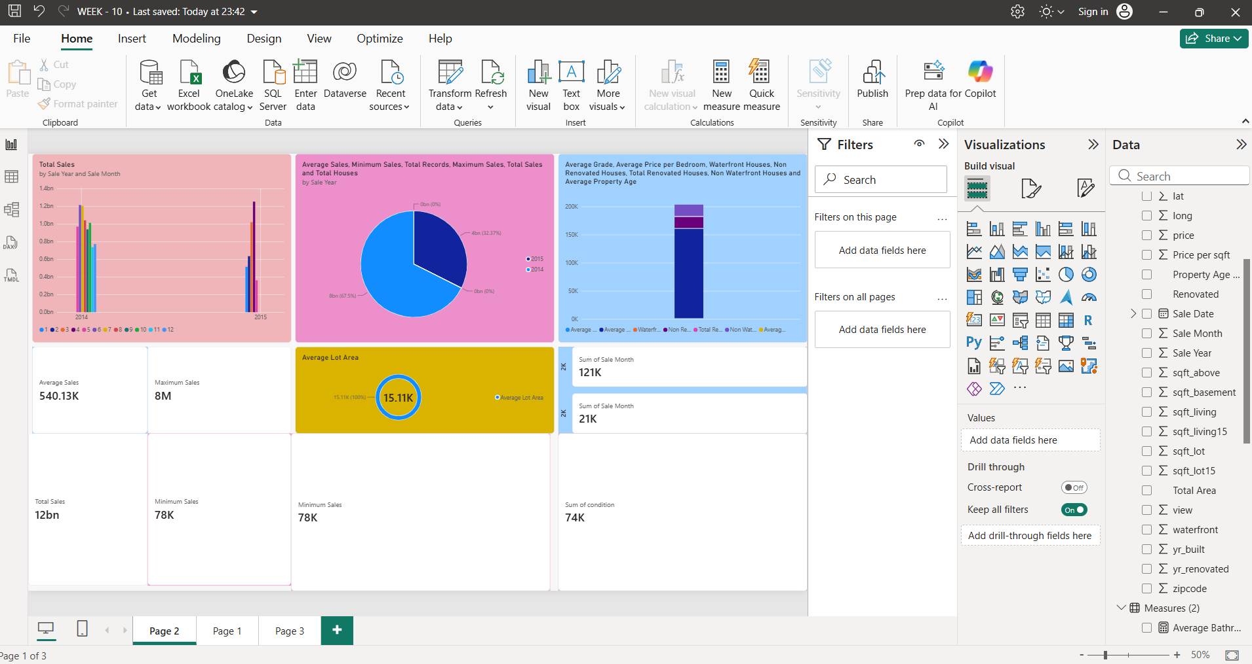

Page 2 – Sales Performance Analysis

. Display total sales by year and month.
. Analyze average, minimum, maximum, and total sales.
. Compare sales performance across different years.
. Analyze waterfront and non-waterfront houses.
. Display average lot area and other important KPIs.

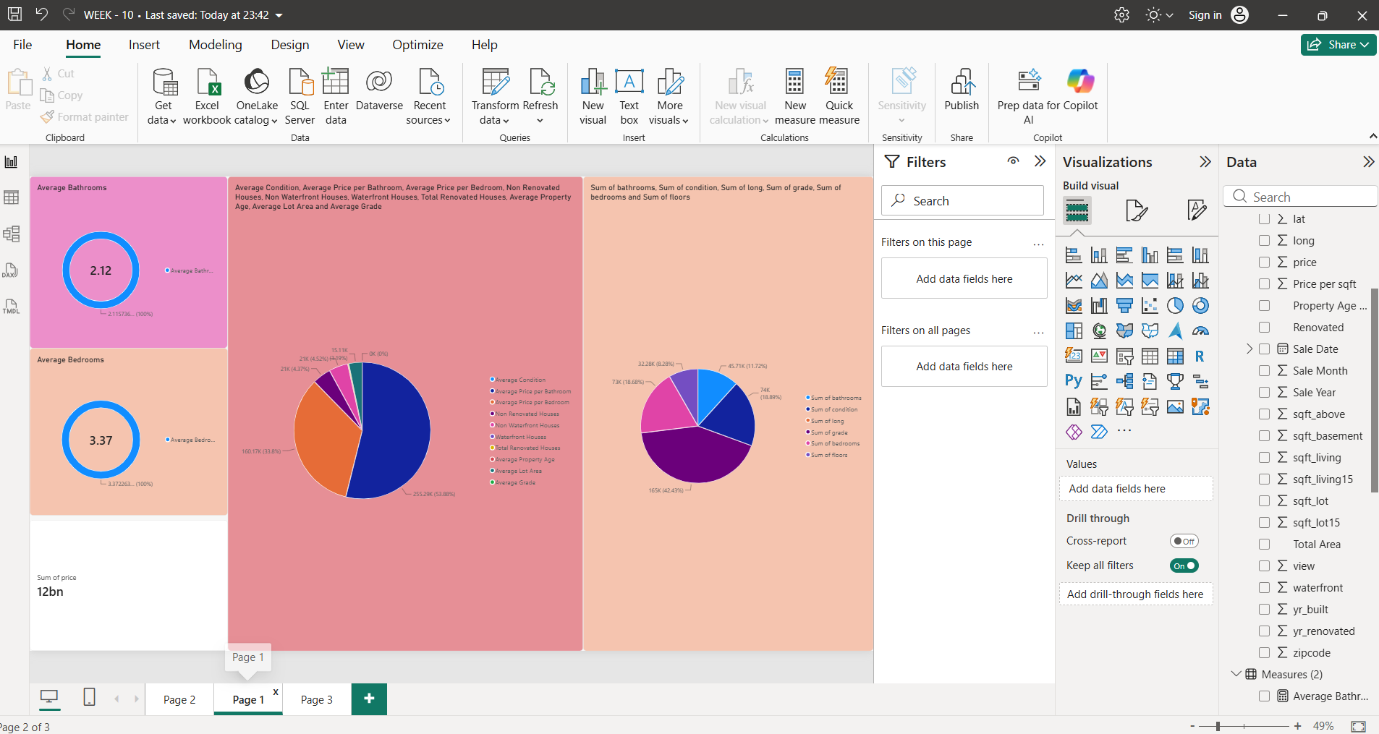

Page 3 – Overall Housing Data Analysis
. Analyze sales year, sale month, and property area.
. Visualize housing data using pie charts and doughnut charts.
. Compare different property measurements and features.
. Present overall housing data distribution.

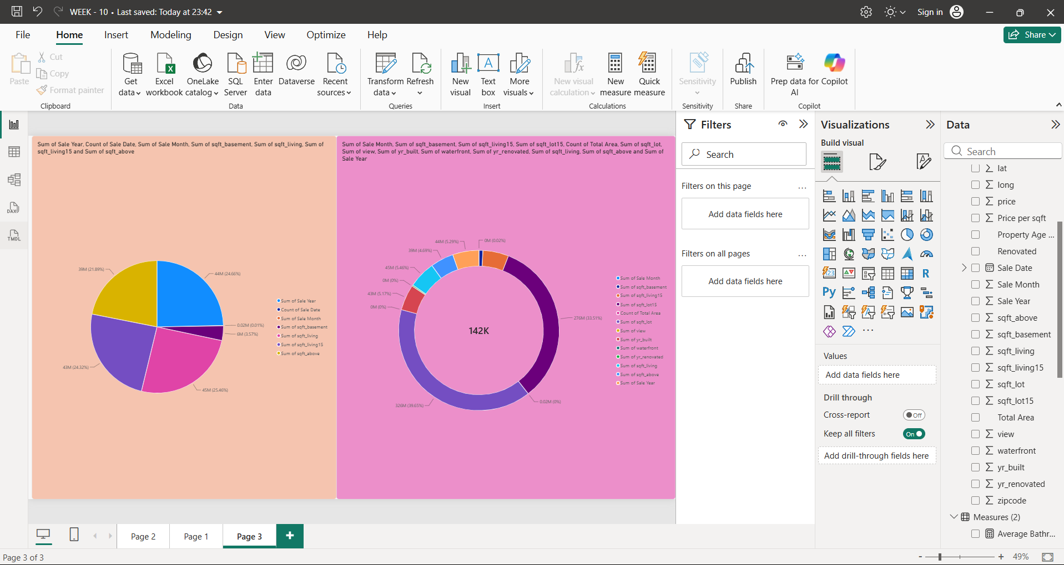

4. Deliverables :
. Cleaned and prepared House Sales dataset.
. Power BI data model.
. DAX measures for key performance indicators.
. Three interactive dashboard pages.
. Visual reports showing property characteristics and sales performance.
. Final Power BI report (.pbix file).

Conclusion :
The House Sales Analysis project successfully demonstrates how Microsoft Power BI can be used to transform raw housing data into meaningful and interactive visual reports. By using data modeling, DAX calculations, KPI cards, pie charts, doughnut charts, and other visualizations, the project provides insights into house prices, sales trends, and property characteristics.
The dashboards help users understand housing market patterns, compare property features, and evaluate sales performance. Overall, this project enhances data analysis and visualization skills and demonstrates how business intelligence tools support informed decision-making.

